**VIETNAM NATIONAL UNIVERSITY, HANOI**

**UNIVERSITY OF ENGINEERING AND TECHNOLOGY**

**SOFTWARE REQUIREMENTS SPECIFICATION DOCUMENTS**

**SEMESTER 232**

**GROUP 10**

**Group members: Phan Anh Tú Student ID: 22028238**

**Mai Anh Tuấn Student ID: 22028144**

**Nguyễn Ngọc Hưng Student ID: 22028142**

**Nguyễn Đức Phát Student ID: 22028298**

**Nguyễn Nhật Phong Student ID: 22028272**

**Course:**  Software Engineering

**Course ID:** INT2208E 23

**Instructor: Assoc. Prof. Đặng Đức Hạnh**

**HÀ NỘI – 2024**

**Software Requirements**

**Specification**

**for**

**Online Ecommerce Website**

**Version 2.0 approved**

**Prepared by Group 10**

**University of Engineering and Technology**

**March 27th, 2024**

|  |  |  |  |
| --- | --- | --- | --- |
| Date | Document version | Description | Author |
| 5th, March, 2024 | 0.1 | **First Draft** | Phan Anh Tú |
| 15th, March,2024 | 1.0 | **Subsection details updated &**  **Example given for each section**  **for easy understanding:**  1. Introduction  2. Overall Description  3. External Interfaces Requirements  4. Analysis Models  4.1.  4.2; 4.3  5. System Features:  5.1 → 5.3; 5.7  5.3 → 5.6  6. Other Nonfucntional Requirements  7. Other Requirements | Phan Anh Tú  Phan Anh Tú  Phan Anh Tú  Nguyễn Đức Phát  Phan Anh Tú  Phan Anh Tú  Nguyễn Ngọc Hưng  Nguyễn Ngọc Hưng  Phan Anh Tú |
| 27th, March, 2024 | 2.0 | **Appendix section updated:**  1. Appendix A: Glossary  2. Appendix B: Field Layouts  **Use Case updated.**  4.1. | Phan Anh Tú, Nguyễn Ngọc Hưng  Phan Anh Tú  Phan Anh Tú |

**Table of Contents**

1. Introduction 8

1.1. Purpose 8

1.2. Intended Audience for the SRS: 8

1.3. Scope 8

1.4. References 9

1.5. Overview 9

2. Overall Description 10

2.1. Product Perspective 10

2.2. Product Functions 10

2.3. User Classes and Characteristics 11

2.4. Operating Environment 12

2.5. Constraints 12

2.6. Assumptions and Dependencies 12

3. External Interfaces Requirements 13

3.1. User Interfaces 13

3.1.1. Home Page 13

3.1.2. Login 14

3.1.3. Create Account 15

3.1.4. My Purchase 16

3.1.5. Shopping Cart 17

3.1.6. My Account 18

3.1.7. Sell 20

3.1.8. Search Bar and Search result page 21

3.1.9. Item View page 21

3.2. Software Interfaces 22

3.3. Communications Interfaces 23

4. Analysis Models 25

4.1. Overall Uses Case Diagram 25

4.2. Customer Use Case Diagram 26

4.3. Seller Use Case Diagram 27

5. System Features 28

5.1. User Accounts 28

5.1.1. Description and Priority 28

5.1.2. Stimulus/Response Sequences 28

5.1.3. Functional Requirements 28

5.2. The search facility 29

5.2.1. Description and Priority 29

5.2.2. Stimulus/Response Sequences 30

5.2.3. Functional Requirements 30

5.3. Shopping cart facility 30

5.3.1. Description and Priority 30

5.3.2. Stimulus/Response Sequences 31

5.3.3. Functional Requirements 31

5.4. Payment 33

5.4.1. Description and Priority 33

5.4.2. Stimulus/Response Sequences 33

5.4.3. Functional Requirements 34

5.5. Order and returns 35

5.5.1. Description and Priority 35

5.5.2. Stimulus/Response Sequences 35

5.5.3. Functional Requirements 36

5.6. Seller features 37

5.6.1. Description and Priority 37

5.6.2. Stimulus/Response Sequences 37

5.6.3. Functional Requirements 37

5.7. Other system features 38

5.7.1. Recommendation Models 38

5.7.2. Rate and Review 38

6. Other Nonfunctional Requirements 38

6.1. Performance Requirements 38

6.1.1. Scalability 38

6.1.2. Response Time 39

6.1.3. Load Testing 39

6.2. Safety Requirements 39

6.2.1. Prevention of Harmful Products 39

6.3. Security Requirements 39

6.3.1. Secure Authentication 39

6.3.2. Secure Payment Processing 39

6.4. Software Quality Attributes 39

6.4.1. Usability 39

6.4.2. Reliability 40

6.4.3. Maintainability 40

6.5. Business Rules 40

6.5.1. User Role Permissions 40

6.5.2. Payment Authorization 40

6.5.3. Order Processing Workflow 40

6.5.4. Return and Refund Policies 41

7. Other Requirements 41

8. Appendix A: Glossary 41

9. Appendix B: Field Layouts 42

9.1. Fields with information required to Login 42

9.2. Fields with information required for Payment 42

**Table of Figures**

Figure 1. System Orgranization chart 10

Figure 2. Home Page view when not logged in 13

Figure 3. Login view 14

Figure 4. Home Page view after logged in 14

Figure 5. Login view when enter incorrect ID or password 15

Figure 6. Sign Up view 15

Figure 7. My Purchase view 16

Figure 8. How to access to My Purchase page 17

Figure 9. Cart view 18

Figure 10. My Profile view 18

Figure 11. Banks & Cards view 19

Figure 12. Addresses view 20

Figure 13. Seller Center view 20

Figure 14. Positioning the "Seller Center" button 21

Figure 15. Search Result page view 21

Figure 16. Order Detail page view 22

Figure 17. Overall Use Case Diagram 25

Figure 18. Customer Use Case Diagram 26

Figure 19. Seller Use Case Diagram 27

1. Introduction
   1. Purpose

The purpose of this software requirement specification is to offer a comprehensive outline of the necessities for an **online ecommerce website**. This document delineates the primary use cases for web customers engaging in online purchases, encompassing both the client and seller components.

The online ecommerce website serves as a virtual marketplace for a diverse array of goods, facilitating global transactions. It operates as an internet-based enterprise with an extensive inventory spanning categories such as books, electronics, groceries, and more.

Sellers utilize this platform to broaden their reach to a global audience, providing enhanced flexibility and market access. The convenience of online shopping has surged in popularity over the past decade, allowing customers to easily explore various products, brands, and price points from the comfort of their homes. This trend has solidified the online shopping website's position as a dominant force in the digital marketplace.

* 1. Intended Audience for the SRS:

The document describes the scope, functionality and features of an online shopping website which has a small group of audience. This document finds relevance to people from various different technical and non-technical backgrounds.

Throughout the document, one becomes familiarized with the scope of these online shopping websites - from their purpose, benefits and business as well as technical constraints. The context and origin of the product as well as its basic functionality are then explained in relevant detail along with an analysis of its different classes, design and implementation. We then detail the interface requirements, build analysis models and examine system features and non functional requirements.

* 1. Scope

The ecommerce website serves as a platform for a diverse range of goods sales and facilitates secure transactions between sellers and customers globally. It operates as a virtual enterprise, offering customers a wide array of products to browse and purchase online. Additionally, it provides sellers with a platform to list their products for customer viewing and purchase. The primary advantages of this service include the convenience of remote shopping, the ability to compare prices, brands, and customer reviews for a deeper understanding of products, and the opportunity for retailers to reach a global audience.

It boasts a comprehensive database storing customer data and purchase history. The reviews section promotes transparency regarding product performance and user experience, featuring both user ratings and detailed reviews with optional product images. This fosters customer trust and community engagement.

Secure transactions and guaranteed, timely product delivery are key features. Increasing sales is a top priority, requiring the testing of various growth strategies such as minimizing management costs, fostering customer loyalty and satisfaction, and leveraging internet resources for technological innovation, marketing, and business development. Continuous research and development, particularly in logistics, are crucial for business growth. Expanding into emerging markets and investing in new ventures are also viable strategies.

The ecommerce website aims to provide a seamless and user-friendly platform for customers to conveniently select from a wide range of products, catering to the needs of both customers and sellers.

* 1. References

**Vietnamese**

* 1. Trương Ninh Thuận; Đặng Đức Hạnh, *Giáo trình Phân tích và thiết kế hướng đối tượng*, Nhà xuất bản Đại học Quốc gia Hà Nội, 2013.

**English**

* 1. Ian Sommerville, *Software Engineering 10th Edition*, Pearson, 2016
  2. Overview

This document is prepared to explain all detailed information about overall system description, functional, non-functional and specific requirements, data and behavioural model description of the system. This document basically consists of three parts: the first part includes introduction and overall description of the application/system/product/software/etc.

The second part contains specific requirements, data and behavioural model description of the system which are section 3, 4 and 5 in the document. Last part gives planning, conclusion and supporting information about the system

1. Overall Description
   1. Product Perspective

The system comprises both user and seller subsystems. The online shopping website provides an excellent means to connect sellers and customers on a digital platform, enabling them to conduct transactions efficiently and securely regardless of physical distance. It offers customers a convenient way to shop online without the need to visit physical stores or meet sellers directly, and provides sellers with a platform to sell their products without the necessity of physical interaction with customers or the setup of physical stores. This system serves as a one-stop destination for customers to choose from millions of online products. Sellers can upload their product listings to the system, while customers can easily browse and shop anytime, anywhere conveniently.

Figure 1. System Orgranization chart

* 1. Product Functions

The website is sketched out to have some basic functions as follows:

* Register an account
* Log in to the website
* Edit account information

***For Users/ Customers:***

* View items
* Search items
* Add items to cart
* View cart
* Change items in cart
* Proceed to buy items
* Delivery and payment
* Shipping tracking
* Order cancellation
* Order return
* Order confirmation
* Item reviews
* Etc.

***Seller:***

* Upload listings
* Edit items
* Items classification
* Delete items
* View order from customers
* Statistics of items sold
* Etc.
* Working with the Options menu bar
* Language options
* Display ads
  1. User Classes and Characteristics

**Customer** - The individual is a verified user of the platform, intending to purchase a product from a seller using the system. They engage in various functions including registration, account viewing, logging in, browsing items, viewing item details, purchasing immediately, adding to cart, viewing cart contents, proceeding to purchase, entering delivery details and payment method, completing payment, placing orders, reviewing past orders, tracking packages, writing reviews, canceling orders, returning items, and logging out.

**Seller** - The individual is a verified user of the product aiming to sell items via the platform. Sellers utilize various product functions such as registration, account viewing, logging in, uploading listings, monitoring sales, and delivering items to customers.

**Administrator** - is responsible for overseeing the following tasks:

* + User and shop owner management, which includes handling accounts, permissions, and any related inquiries or issues.
  + Reporting management and processing, involving the analysis of sales data, customer trends, and other relevant metrics to inform decision-making.
  + Web maintenance duties, which encompass ensuring the website's functionality, security, and performance are optimized. This includes regular updates, troubleshooting, and addressing any technical issues that may arise.
  1. Operating Environment

There is only one modes of using the software - **web applications**. Web applications can be run on Windows 7/8/8.1/10/11: Google Chrome (78 and later); Mozilla Firefox (70 and later); Internet Explorer (11 and later); Microsoft Edge (18.18362 and later), Mac OS X: Apple Safari (13.0.1 and later). The Internet is a basic necessity for the system to be accessed.

Front End JS / HTML / CSS

Backend NodeJS / MySQL

* 1. Constraints

For maintenance convenience, customers are only allowed to make payments after adding items to their cart; proceeding directly to checkout with an empty cart is not an option. Specific brand-related agendas are not incorporated into our design. Sections showcasing daily deals, gifting options, and sales are omitted. The wish list feature is merged with the cart due to their similar purposes. While some platforms have experimented with building friendship communities among customers, concerns about transparency regarding product costs and personal spending within these communities pose privacy risks and limit developers' options. Real-time update capability in such systems places high demands on server capacity to handle sudden spikes in traffic. Interfaces with payment methods like Google Pay or PayPal increase the risk of middle attacks, necessitating additional security measures at payment gateways. The recommendation system is assumed to operate on the server side. Our system prioritizes customer needs over those of sellers, with more detailed functionalities designed for customers than for sellers. The system is developed by JS / HTML / CSS and NodeJS / MySQL as back end

* 1. Assumptions and Dependencies

The tool must feature a user-friendly interface that is easy to comprehend. All essential hardware and software required for implementing and utilizing the tool are readily available. The system will be created, built, and put into operation according to the specifications outlined in the software requirements document. Initially, only one customer can place an order simultaneously, but efforts will be made to broaden this capability. The recommendation models will rely on server functionalities, with the server defining recommendations more explicitly relevant to customers.

1. External Interfaces Requirements
   1. User Interfaces
      1. Home Page

Figure 2. Home Page view when not logged in

* + The home page of this ecommerce website is designed to be attractive and user – friendly
  + It includes: search bar, buttons and links such as Login, Sign Up, Cart, Notifications, Seller Center, Start Selling, Change Language option, Username, and several suggestions based on their recently search
  + It also showcases the best-selling items across popular categories such as electronics, clothes, watches, and more. It promotes ongoing sales, discounts, and special offers.
    1. Login

Figure 3. Login view

* + This webpage enables users with an existing account within the online shopping platform to log in similar to Figure 2. Users have the option to sign in using either their phone number, username, email address associated with their account. In the early version, user can just sign in by their email. After entering their email address or phone number along with the corresponding password, the user can click on the "LOG IN" button. If the entered credentials are correct, the system will redirect the user to the homepage, and their username will be displayed on the top navigation bar as shown in Figure 3.

Figure 4. Home Page view after logged in

* + If the entered email address or phone number is incorrect, the system will display an error message stating "Your account and/or password is incorrect, please try again." as shown in Figure 4.

Figure 5. Login view when enter incorrect ID or password

* + The sign-in page also includes a "Sign Up" button for new users. When clicked, this button redirects the user to the Sign Up page.
  + Additionally, there are other fields such as "Forgot Password" and "Need Help" provided on the sign-in page. Clicking on these options directs the user to the appropriate pages for password recovery or assistance.
    1. Create Account



Figure 6. Sign Up view

* + This webpage illustrated in Figure 5 permits users to register a new account. Users are prompted to enter their name, email address, and password. The password field requires a minimum of 6 characters.
  + Additionally, users are required to confirm their password by re-entering it. Following this step, users can proceed to create a new account by clicking the 'Create your account' button.
  + This webpage also offers additional sections such as 'Conditions of Use,' 'Privacy Notice,' and 'Help,' which direct users to the relevant pages for more information.
  + This page includes a sign-in field designed for users who already possess an account. After selecting the sign-in field, users who already have an account will be directed to the sign-in page for authentication purposes.
    1. My Purchase

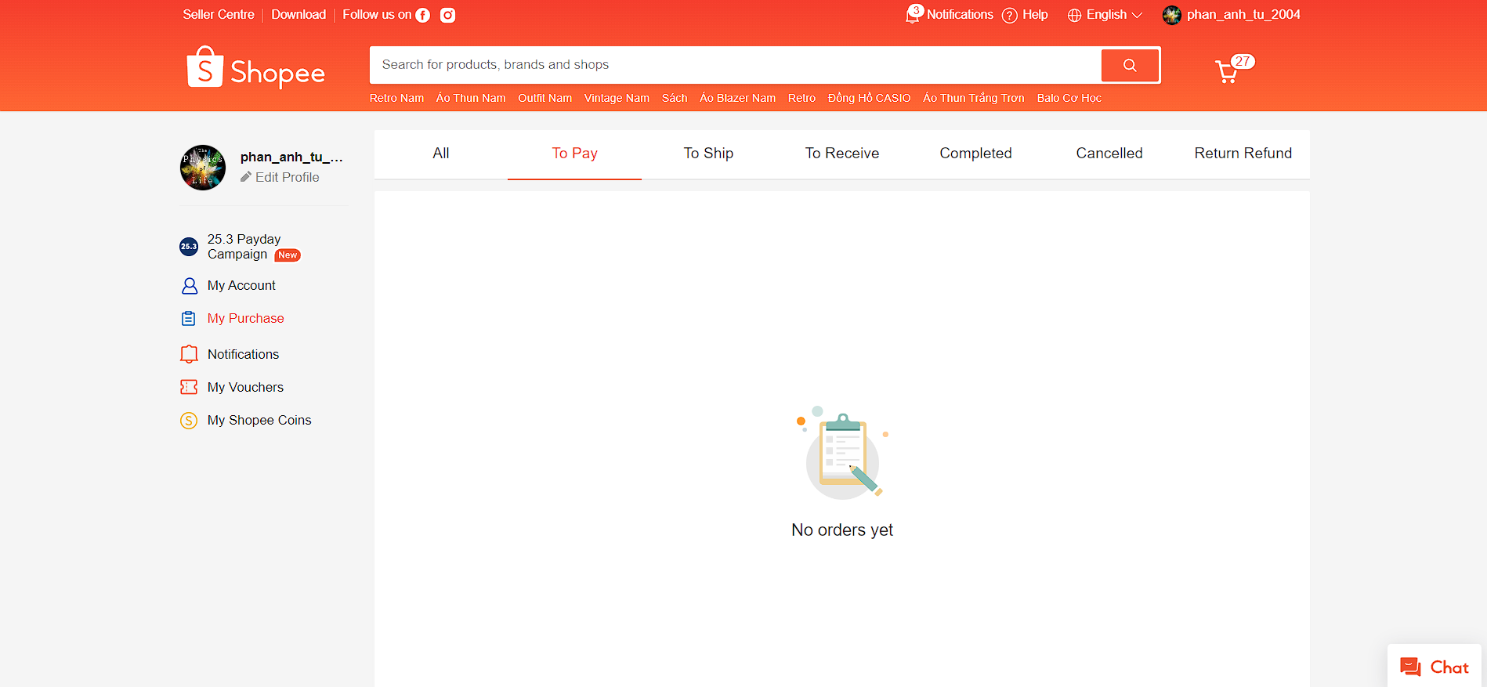

Figure 7. My Purchase view

* + This page furnishes users with comprehensive details regarding their orders. It encompasses various categories such as 'All’, 'To Pay’, 'To Ship’, 'To Receive’, 'Completed’, 'Cancelled’, and 'Return Refund’.
  + To access this page, users should navigate to the username button located in the top right corner of the webpage. Upon hovering or clicking on this button, a dropdown menu will appear, presenting a list of choices. From this menu, users should select 'My Purchases'. (Figure 7)

Figure 8. How to access to My Purchase page

* + The “All” section includes the rest sections: 'To Pay’, 'To Ship’, 'To Receive’, 'Completed’, 'Cancelled’, and 'Return Refund’.
  + The “To Pay” section gives the information about all the orders that users placed, but haven’t purchased yet. You can purchase online right away by clicking to the “PURCHASE” button corresponding to the order you want.
  + The “To Ship” section gives users information about all the orders that have been forwarded to the seller for delivery to the shipping company. In that section, there is a “CANCEL” button for each order detail, means that users can cancel the order during the time the seller deliver the order to the shipping company, and that order detail will move to the “Cancelled” section
  + The “To Receive” section provides users with information about orders that are currently en route to them. Once your order has appeared in this, you can check its shipping journey. When the order arrive their place, there is a “CONFIRM” button, and the user hit that button only after receiving the order
  + The “Complete” section consists of the order have been successfully delivered to the users. The users now can rate the order as well as comment about the quality of the order so that later user and base on these rates and comment to consider whether or not to buy it. Additionally, there is a “Buy Again” button, “Contact seller” button, and for 7 days from receipt of goods, users can see the “Return Request” button. When clicking on that button, the return request will be sent to the seller and that order will be moved to the “Return Refund” section
    1. Shopping Cart
  + This page as shown in Firgure 8 allows the user to save the items they wish to buy in the cart. It provides information about all the items added to the cart by the user. For each item in the cart functionalities like ‘Delete’ and ‘Find similar’ are provided to the user.

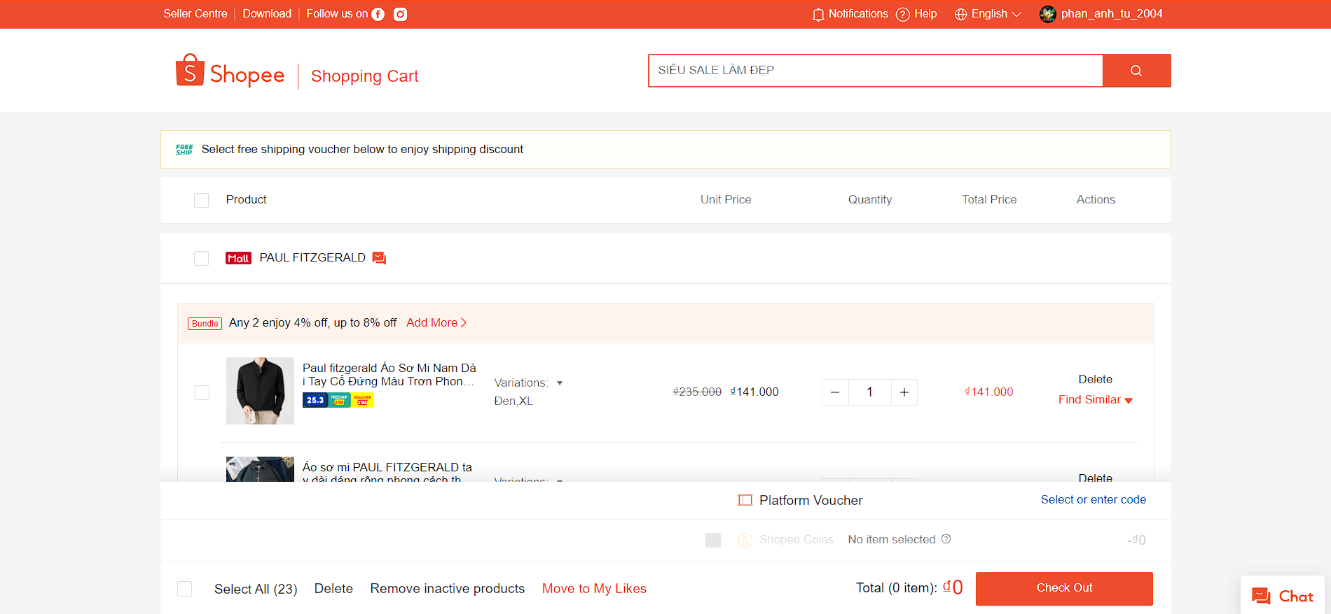

Figure 9. Cart view

* + The user can select all the items they wish to buy from the cart by clicking the checkbox next to each item. The user can then select the ‘Proceed to check out’ button to proceed with purchasing the item(s).
    1. My Account

Figure 10. My Profile view

* + My Account page comprises of several section:
    - Profile: where users can edit name, email, gender, date of birth and avatar (Figure 9)
    - Banks & Cards: where users can add credit cards or bank accounts for online purchase by clicking “Add new Card” and “Add new Bank Account” button, respectively (Figure 10)
    - Addresses: users can set addresses for order shipping. There is a “Add new Address” button for this purpose. Users can also edit, or delete existing addresses as well as set default address if there are more than one addresses.

Figure 11. Banks & Cards view

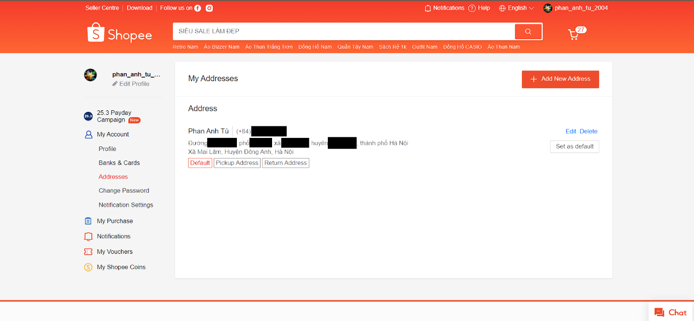

Figure 12. Addresses view

* + 1. Sell

Figure 13. Seller Center view

* + This webpage facilitates users to become sellers on the online shopping platform. Users interested in selling their products need to register as a seller. Registration involves providing various details about themselves and their business, including business location, business type, contact address, identity information, GST number, and bank account details.
  + After successfully registering as a seller, users are required to upload their product listings onto the online shopping platform. Customers can then browse and purchase the seller's products. The seller is responsible for delivering the products to the customers and receiving payment for the transactions.

Figure 14. Positioning the "Seller Center" button

* + To access this page, users just click to the “Seller Center” button displayed on the top left side at the Home page
    1. Search Bar and Search result page
  + Customers can utilize the "Search Bar" adjacent to the logo to swiftly and effortlessly conduct product searches, enabling them to find desired items promptly. Positioned within the top navigation bar, the search feature is prioritized, emphasizing its significance in the online shopping website's user experience.

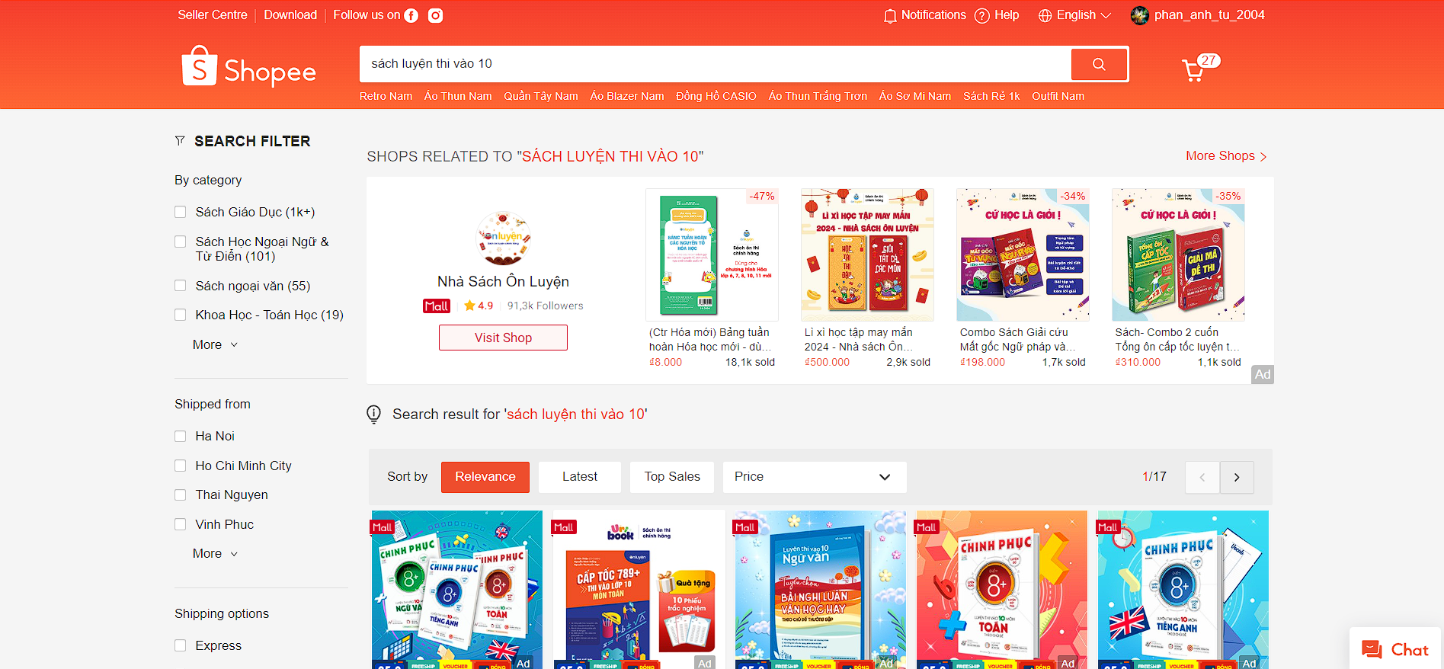

Figure 15. Search Result page view

* + After you search for a keyword for the item you want to buy, the website will display search results for that item. Users can click on an item to view details of that item, or can filter search results by criteria such as category, shipping from, price,... (Figure)
    1. Item View page

Figure 16. Item View page view

* + Users can click on products while searching to view comprehensive information about them.
  + Typically, this includes one or more images of the product, the product's name, features, price, and the brand selling it.
  + After reviewing the product details, users can proceed to add the product to their cart or purchase it directly by clicking on the 'Add to Cart' or 'Buy Now' buttons, respectively.
  + Upon clicking the ‘Buy Now’ button, the user will be prompted to choose a payment method. After selecting the preferred payment method, they can proceed by clicking the ‘Continue’ button to finalize the order placement process.
  + Users are presented with the billing details of the product. Additionally, they have the option to review the order, make adjustments to the delivery address if needed, and then finalize the process by clicking on the ‘Place Your Order’ button to complete the order placement.
  + Once the user's order is successfully placed, they will receive a notification message to their phone number confirming the order.
  1. Software Interfaces
  + All the web pages of this online shopping website are primarily constructed using development tools such as HTML, CSS, JavaScript, and other related technologies.
  + This online shopping website is accessible through the internet on any operating system, including Unix, Linux, Mac, Windows, and others.
  + This system stores product data, customer data, and seller data in multiple databases housed within data centers situated across various geographical locations. The primary type of database used is MySQL.
  + The online shopping website will communicate with the content manager to retrieve product specifications for users on the Product Specification page.
  + The system's databases store comprehensive information about the products. The content manager retrieves various details about the product, including images, product name, features, price, brand selling it, product reviews, ratings, etc., which are then displayed to the users.
  + The system will communicate with the bill-paying system to identify available payment methods, validate payments, and process transactions. It will share data including customer email/phone number, selected payment method, product IDs, quantities, prices, and payment details such as card number, name on the card, expiration date, etc., with the bill-payment system for processing.
  + The system will interact with the credit management system to manage financing options. It will share data including the total price, payment method, and payment details with the credit management system for processing financing options.
  + The system will communicate with the Sales system for order management. The Sales system will handle orders placed by customers, taking into account order details, the date and time of the order, delivery addresses, and approximate delivery dates.
  + The system will interact with the shipping system to track orders and update shipping methods. After an order is placed, the shipping system takes charge of informing users about the shipping progress of their ordered products. These updates are communicated to customers via messages sent to their phone numbers and email addresses.
  1. Communications Interfaces
  + Users can access the online shopping website via the internet by searching for the system's name in a web browser.
  + The system will utilize the HTTP protocol for communication over the internet.
  + Upon placing an order, the system will send a confirmation message to the customer's email address and phone number, indicating that their order has been successfully placed.
  + Additionally, the system will provide follow-up messages to the customer's phone number and email address to keep them informed about the shipping process, including updates such as 'product is dispatched from the site' and 'product is expected to arrive in 2 days', etc.

1. Analysis Models
   1. Overall Uses Case Diagram

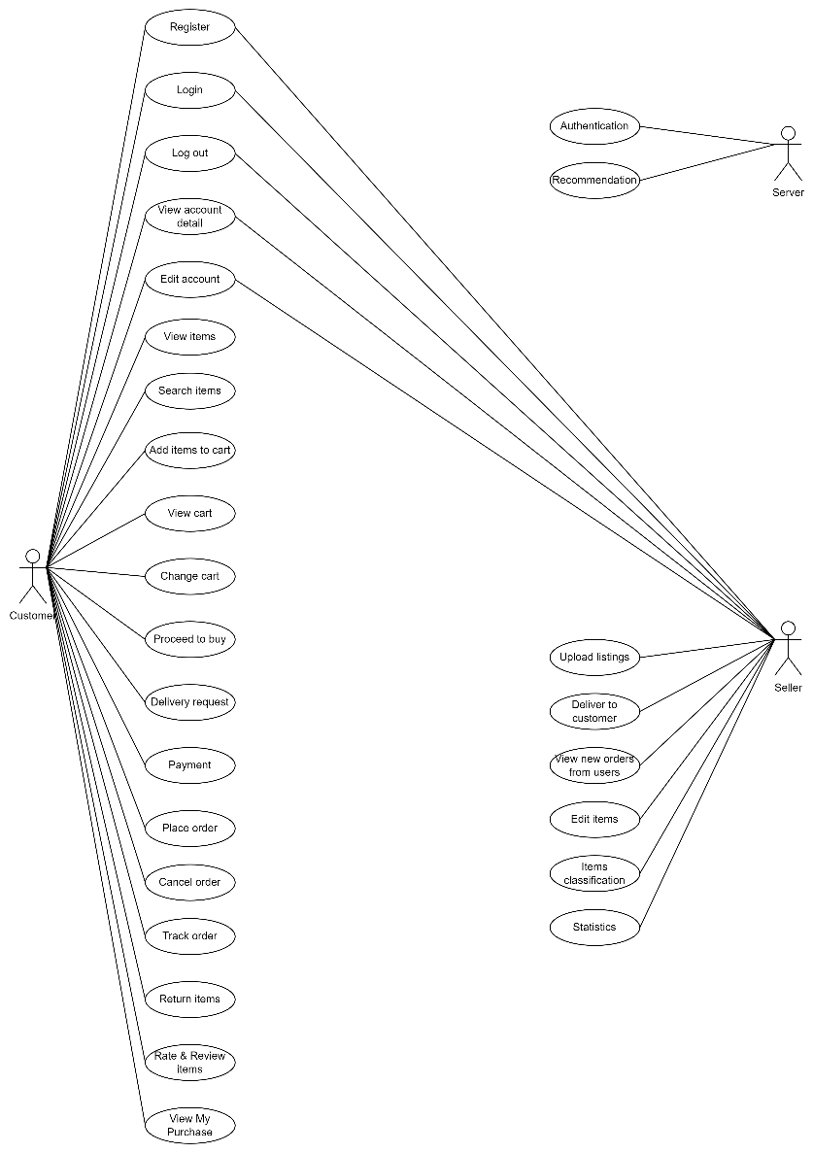

Figure 17. Overall Use Case Diagram

* 1. Customer Use Case Diagram

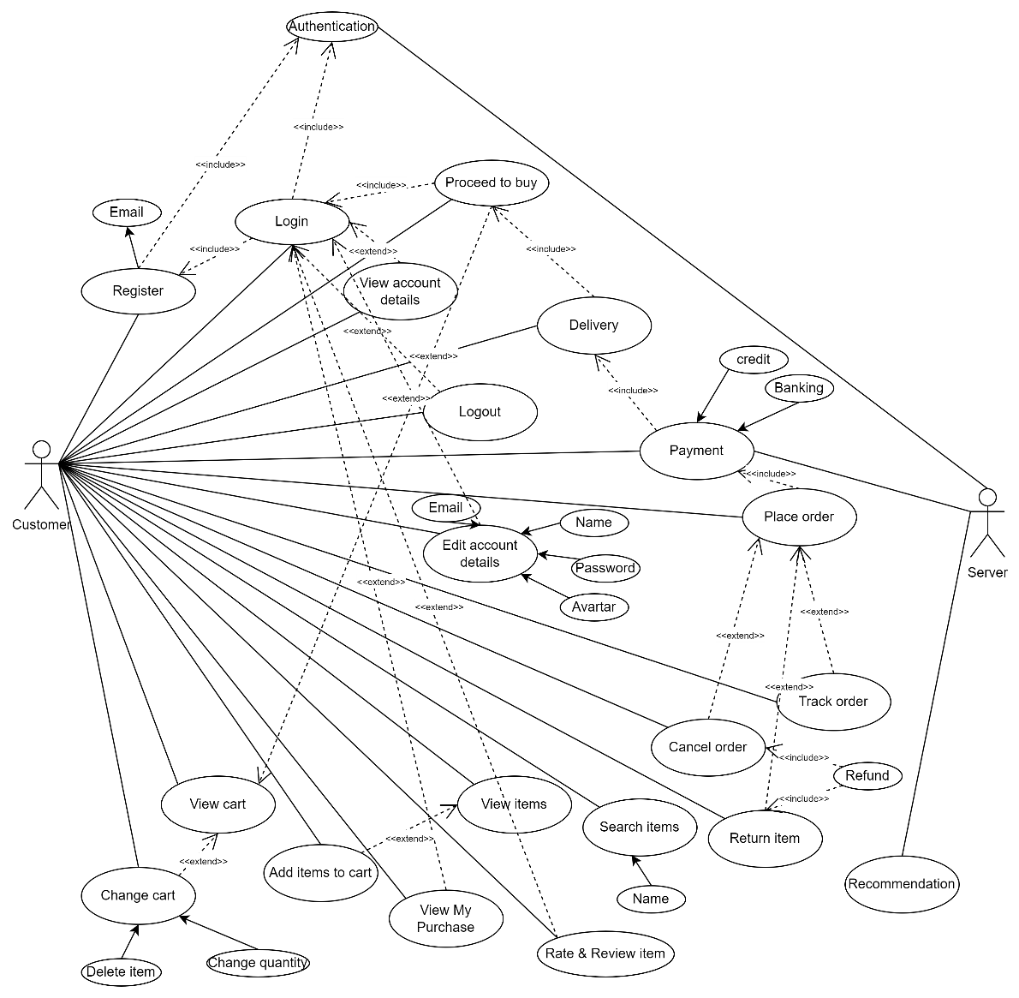

Figure 18. Customer Use Case Diagram

* 1. Seller Use Case Diagram

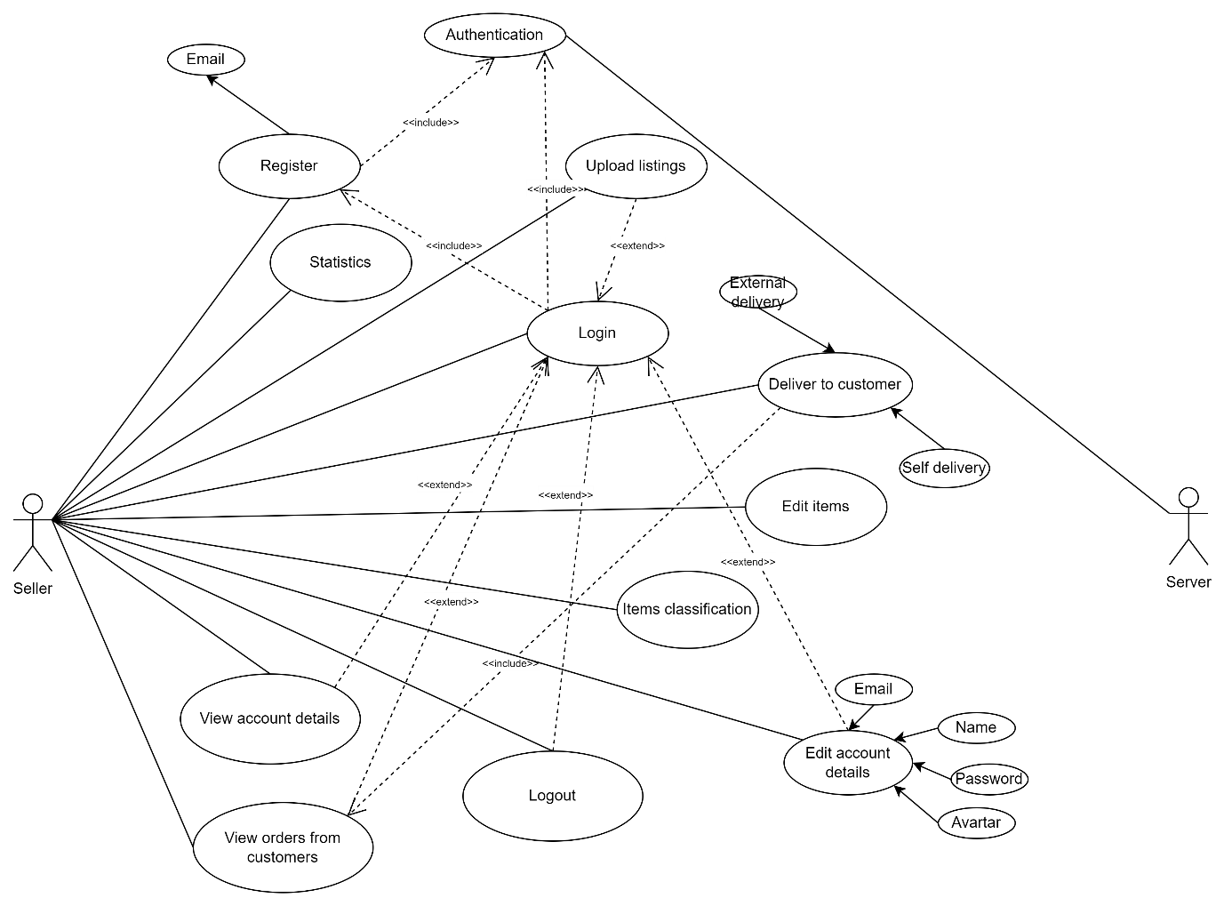

Figure 19. Seller Use Case Diagram

1. System Features
   1. User Accounts
      1. Description and Priority

Both customers and sellers are required to have accounts in the shopping system to engage in transactions. Users without accounts are limited to browsing permissions from the homepage and cannot make purchases or list goods. Customer accounts will contain details such as their name, email address or phone number, and password. Both types of users can access and modify their account details in the future. Seller accounts will include information pertinent to the selling entity or individual, such as name, contact information, GST number, PAN number, licenses, and address.

**Priority level**: High

* + 1. Stimulus/Response Sequences

On the homepage, users can choose either the signup or login option and input their details for registration or login accordingly. If the provided information meets the necessary criteria, an account will be created, and users will be directed to the login page, or they will be logged into their account and redirected to the homepage.

Account details can be edited or viewed by clicking on the appropriate buttons. When editing details, users can input new information and save changes. Once the changes are verified, the updated details are successfully applied.

* + 1. Functional Requirements

**REQ – 1: Register**

* Users: Both customers and sellers
* Input: Provided on the signup page:
  + For Customers: Name, email address/phone number, and password
  + For Sellers: Name, email address/phone number, and GST number
* Output: Successful registration results in the display of the login page
* Alternative Flow(s):
  + If the provided email address or phone number is already in use or invalid:
    - Prompt the user to re-enter a valid choice

**REQ-2: View Account Details**

* User: Customers and sellers
* Input: Clicking the "view account details" button on the homepage
* Output: Displays the account details provided by the user during account creation
* Alternative Flow(s): None

**REQ-3: Login**

* User: Customers and sellers
* Input: On the login page:
  + For Customers: Enters registered email address/phone number and password
  + For Sellers: Enters registered email address/phone number and password
* Output: Successful login results in displaying the homepage
* Alternative Flow(s):
  + If the entered email address/phone number is invalid or doesn't match the password:
    - Prompt the user to re-enter valid credentials

**REQ-4: Logout**

* User: Customers and sellers
* Input: Clicking the "logout" button on the homepage
* Output: User is logged out of the account, and the login page is displayed
* Alternative Flow(s): None

**REQ-5: Edit Account Details**

* User: Customers and sellers
* Input: On the homepage
  + Navigate to the username button located in the top right corner of the webpage, hovering this button and choose “My Account”
  + Select the detail to be edited
  + Enter the new details
  + Click "Save"
* Output: Successfully updated
* Alternative Flow(s):
  + If the entered details are invalid:
    - Prompt the user to re-enter valid credentials
  1. The search facility
     1. Description and Priority

To search for items within the extensive catalogue of products in the shopping system, customers can opt to search for a product by entering keywords related to the desired item. Relevant options are available in a dropdown menu within the search bar. Upon selection, the system displays products related to the keyword entered or the image uploaded by the customer.

**Priority level**: High

* + 1. Stimulus/Response Sequences

1. **Search for a product**
   * Stimulus: customer enters keywords into the search box.
   * Response: dropdown menu immediately appears, suggesting the most relevant products based on the entered keywords.
     1. Functional Requirements

**REQ-1: Search Item**

* User: Customers
* Input: On the homepage,
  + Click on the browse button
  + Enter keywords related to the item such as item name or brand
* Output: Displays a list of products related to the searched item
* Alternative Flow(s):
  + If no results are found for the searched term/keyword:
    - Display message: "No results found for the searched term/keyword. Please check your spelling or try using more general terms."

**REQ-2: View Item**

* User: Customers
* Input: From the list of items, click on an item to view its details
* Output: Details of the selected item are displayed, including price, brand, size, material, quantity, delivery date, images of the item, along with ratings and reviews. An "add to cart" button is also provided.
* Alternative Flow(s): None
  1. Shopping cart facility
     1. Description and Priority

Once the customer views and chooses an item they want to purchase, they must add the item to their cart using the "add to cart" button. The shopping cart holds all the items the customer intends to buy, with each user account having its own associated shopping cart. Users can browse for items, add them to the cart, and seamlessly continue shopping. They have the option to purchase all items in the cart at once when they're ready.

**Priority level**: high

* + 1. Stimulus/Response Sequences

1. Add items to cart
   * Stimulus: Customer must click on the add item to cart button on the item view page
   * Response: The system will add the requested item to the user's cart.
2. View all the item in cart
   * Stimulus: The customer clicks on the view cart button.
   * Response: A list of all items along with price of individual item, quantity and total cost of the cart is displayed
3. Change items in cart
   * Stimulus: Customer has the option to remove items from the cart or change the quantity of the products by clicking on the delete item button next to the item or ‘plus’ or ‘minus’ symbols respectively
   * Response: The item will be deleted or its quantity will change respectively
4. Proceed to buy
   * Stimulus: The customer clicks on the proceed to buy button
   * Response: The system will navigate to the payment page
5. Continue shopping
   * Stimulus: The customer clicks on the continue shopping button
   * Response: Going back to the home page
     1. Functional Requirements

**REQ-1: Add Item to Cart**

* User: Customers
* Input: On the view item page,
  + Click on the "add item to cart" button
* Output: The item is added to the cart, and the user remains on the same page.
* Alternative Flow(s):
  + If the item being added is already in the cart:
    - Increase the quantity of that item by 1 in the cart.

**REQ-2: View Shopping Cart**

* User: Customers
* Input: Available on all pages,
  + Click on the "view cart" button
* Output: Displays a list of items that were added to the cart, along with their details and the total cost.
* Alternative Flow(s):
  + If the cart is empty:
    - Display "cart empty" and provide an option to return to the homepage by clicking on "continue shopping".

**REQ-3: Change Items in Cart**

* User: Customers
* Input: On the shopping cart page,
  + Click on the "delete item" button next to the item to remove it from the cart.
  + To change the quantity of items, click on "+" to increase the quantity by 1, or "-" to decrease it by 1.
* Output: Changes are reflected on the shopping cart page based on the performed activity. The item will be removed from the page if deleted.
* Alternative Flow(s): None

**REQ-4: Proceed to Buy**

* User: Customers
* Input: On the shopping cart page,
  + Click on the "proceed to buy" button
* Output: Displays the payment page.
* Alternative Flow(s): None

**REQ-5: Continue Shopping**

* User: Customers
* Input: On the shopping cart page,
  + Click on the "continue shopping" button
* Output: Displays the homepage.
* Alternative Flow(s): None
  1. Payment
     1. Description and Priority
  + Description: This feature involves handling payments within the system, allowing users to make purchases securely.
  + Priority: Medium
    1. Stimulus/Response Sequences

1. **User initiates checkout process**
   * Stimulus: User clicks on the “Check out” button after reviewing their bills
   * Response: System displays the checkout page with payment options.
2. **System presents payment options:**
   * Stimulus: System loads the checkout page.
   * Response: System presents various payment methods such as credit/debit cards, PayPal, and other options.
3. **User selects preferred payment method:**
   * Stimulus: User selects a payment method from the available options.
   * Response: System displays relevant fields for the selected payment method (e.g., card details, PayPal login).
4. **System processes payment:**
   * Stimulus: User submits payment information.
   * Response: System securely transmits payment data to the selected payment gateway for processing.
5. **Payment gateway sends confirmation to the system:**
   * Stimulus: Payment gateway processes the payment request.
   * Response: Payment gateway sends a confirmation response (success or failure) to the system.
6. **System updates order status and sends confirmation to the user:**
   * Stimulus: System receives payment confirmation from the gateway.
   * Response: System updates the order status to "paid" and generates an order confirmation message to be sent to the user via email
     1. Functional Requirements
7. **Valid methods display**
   * User (Customers): Click to “Check out” button.
   * Input: The signal indicates that user has clicked “Check out” button.
   * Output: A checkout page with valid payment options.
   * Alternative flow: nothing.
8. **Showing exactly the method that the user chooses**
   * User (Customers): Choose method and verify
   * Input: The method that user chose.
   * Output: 1 page displaying payment interface by the method that the user wants
   * Alternative flow:
     + The desired user method has not been updated by the system => Suggest user to choose another method or pay in cash
9. **Payment Submission Handling.**
   * User (Customers): The user submits the payment information for processing.
   * Input: User confirms the payment details and clicks on the "Submit Payment" button.
   * Output: The system securely transmits the payment information to the payment gateway for processing.
   * Alternative Flow: If the payment gateway encounters an error or is temporarily unavailable, the system notifies the user and prompts them to retry the payment or select an alternative method.
10. **Confirmation of Successful Payment.**
    * User (Customers): The user receives confirmation of successful payment processing.
    * Input: User waits for confirmation after submitting payment information.
    * Output: Upon successful payment processing, the system updates the order status to "paid" and sends an order confirmation email to the user.
    * Alternative Flow: If the payment processing takes longer than expected, the system informs the user of the delay and assures them that their payment is being processed.
11. **Error Handling during Payment.**
    * User (Customers): The user encounters an error during payment processing.
    * Input: User receives an error message indicating payment processing failure.
    * Output: The system displays an error message and provides instructions for resolving the issue or selecting an alternative payment method.
    * Alternative Flow: If the error persists or the user cannot resolve it, the system offers customer support contact information for further assistance.
12. **Order Confirmation and Status Update.**
    * User (Customers): The user completes the payment process and receives an order confirmation.
    * Input: User confirms successful payment processing and awaits order confirmation.
    * Output: The system updates the order status to "paid" and sends an order confirmation email to the user.
    * Alternative Flow: If the user does not receive the order confirmation email within a reasonable time frame, the system provides a link for the user to check their order status manually or contact customer support for assistance.
    1. Order and returns
       1. Description and Priority
    * Description: The "Order and Returns" feature facilitates the management of orders and returns within the system. It is used to help sellers manage orders as well as help users to view the orders they have bought
    * Priority: Medium
      1. Stimulus/Response Sequences
13. User places an order:
    * Stimulus: User adds items to the cart and proceeds to checkout.
    * Response: System displays order summary and prompts user to confirm the order.
14. **User initiates a return request:**
    * Stimulus: User selects an order from their order history and requests a return.
    * Response: System displays return options and prompts user to provide reason for return.
15. **System processes return request:**
    * Stimulus: User submits return request with required information.
    * Response: System acknowledges return request and provides return instructions.
      1. Functional Requirements
16. **Order Placement and Confirmation**
    * User (Customers): User adds items to the cart and proceeds to checkout.
    * Input: User selects items and enters shipping/payment details.
    * Output: System displays order summary and prompts user to confirm.
    * Alternative Flow: If user encounters an error during checkout, system provides error message and prompts user to correct input.
17. **Return Request Handling**
    * User (Customers): User selects an order from their order history and requests a return.
    * Input: User selects items for return and provides reason.
    * Output: System acknowledges return request and provides return options.
    * Alternative Flow: If return request is invalid (e.g., beyond return window), system displays error message and prompts user to revise request.
18. **Return Processing and Refunds**
    * User (Customers/Sellers): User submits return package and seller receive information about package returned.
    * Input: User sends returned items according to provided instructions.
    * Output: System confirms receipt of return package and initiates refund process.
    * Alternative Flow: If returned items are damaged or incomplete, system notifies user and adjusts refund accordingly.
    1. Seller features
       1. Description and Priority
    * Description: The Sellers features encompass functionalities tailored to users acting as sellers within the system. Some functions can be mentioned as: managing items, viewing more than goods or offering incentives.
    * Priority: High
      1. Stimulus/Response Sequences
19. Seller registers an account:
    * Stimulus: Seller navigates to the registration page and fills out the required information.
    * Response: System verifies the information provided and creates a seller account.
20. Seller lists a product for sale:
    * Stimulus: Seller accesses the product listing page and provides details of the item to be listed.
    * Response: System validates the listing information and adds the product to the marketplace.
21. Seller manages product inventory:
    * Stimulus: Seller accesses the inventory management section to update product quantities and attributes.
    * Response: System updates the product inventory and reflects changes in the marketplace.
      1. Functional Requirements
22. **Seller Account Management**
    * User (Sellers): Seller navigates to the account settings page.
    * Input: Seller updates personal information, payment details, and other account settings.
    * Output: System saves the changes and reflects them in the seller's account profile.
23. **Product Listing and Management**
    * User (Sellers): Seller accesses the product listing page.
    * Input: Seller provides product details, including title, description, price, and images.
    * Output: System validates the listing information and adds the product to the marketplace.
24. **Inventory Management**
    * User (Sellers): Seller navigates to the inventory management section.
    * Input: Seller updates product quantities, attributes, and availability status.
    * Output: System updates the product inventory and reflects changes in the marketplace.
    1. Other system features
       1. Recommendation Models

The server is tasked with managing the recommendation model, which is utilized to personalize the products displayed to customers on their homepage. These models are constructed using collaborative filtering techniques.

* + 1. Rate and Review

The client subsystem offers rate and review functionalities to foster a consumer community. Customers can provide feedback on purchased products by assigning ratings or expressing satisfaction levels. The system may decide to discontinue products with low satisfaction ratings.

1. Other Nonfunctional Requirements
   1. Performance Requirements

The structure and management of the information system can significantly impact performance in the following manners:

* + 1. Scalability
  + The website shall be able to handle a large number of concurrent users and transactions without experiencing significant performance degradation. The system should be able to scale horizontally by adding more servers to the system as needed.
    1. Response Time
  + The website shall be responsive and provide a good user experience. The response time for all pages and transactions shall be within 2 seconds.
    1. Load Testing
  + The website shall be load tested to ensure that it can meet the performance requirements. Load testing shall be performed using a variety of tools and techniques, such as JMeter and Gatling.
  1. Safety Requirements
     1. Prevention of Harmful Products
  + The system must incorporate measures to prevent the listing, promotion, or sale of harmful or prohibited products to users.
  + Implement content filtering mechanisms to detect and flag products that pose potential risks to users' health, safety, or well-being.
  1. Security Requirements
     1. Secure Authentication
  + Implement robust authentication mechanisms, such as multi-factor authentication (MFA) or strong password policies, to verify the identity of users and prevent unauthorized access to accounts.
    1. Secure Payment Processing
  + Payment processing must encrypt sensitive payment data and adhere to industry best practices for handling financial transactions.
  1. Software Quality Attributes
     1. **Usability**
  + Ease of Navigation: Users should be able to find desired products and complete purchases intuitively. The website should have a clear and consistent navigation structure with easily identifiable menus and search functions.
  + Task Completion Time: Users should be able to complete core tasks like product browsing, adding items to cart, and checkout within a reasonable timeframe. Aim for an average task completion time of under 3 minutes.
  + Error Prevention and Recovery: The website should prevent common user errors through clear instructions and input validation. When errors occur, provide user-friendly error messages and clear paths for recovery
    1. Reliability
  + Error Rate: The website should have a low error rate, with minimal occurrences of bugs or crashes that could disrupt user experience. Aim for a defect escape rate of 95% or higher.
  + Data Consistency: Data stored in the system, such as product information and user accounts, should be consistent and accurate across all instances.
    1. Maintainability
  + Modular Design: The website should be built using a modular architecture that allows for easy modification and addition of new features.
  + Code Documentation: The website code should be well-documented with clear comments and explanations to facilitate future maintenance and updates.
  1. Business Rules
     1. User Role Permissions
  + Different user roles have specific permissions and restrictions within the system. For example:
  + Administrators have the authority to add, edit, or delete user accounts and access all features and functionalities.
  + Regular users can only access certain functionalities such as browsing products, making purchases, and updating their profiles.
    1. Payment Authorization
  + Only authorized personnel or payment gateways can process payments and complete transactions. This ensures compliance with financial regulations and prevents unauthorized access to payment information.
    1. Order Processing Workflow
  + Orders must follow a predefined workflow for processing, including steps such as order verification and payment confirmation. This ensures consistency and efficiency in handling orders and fulfillment.
    1. Return and Refund Policies
  + The system enforces predefined return and refund policies, specifying conditions under which customers are eligible for returns or refunds. This ensures consistency and fairness in handling customer inquiries and disputes.

1. Other Requirements

A strong commercial backend system is essential for accurately distinguishing between customer and seller details. Additionally, a comprehensive management backend is needed to handle inventory and meet general system requirements. Authorization from payment services is crucial to enable customers to make payments via payment gateways. It's imperative to have a clearly defined privacy policy, two-step verification via external mail to safeguard against any breaches in both user and system data.

1. Appendix A: Glossary

|  |  |  |
| --- | --- | --- |
| **Term** | **Expansion** | **Meaning** |
| Scalability |  | refers to the ability of a system, network, or process to handle a growing amount of work, or its potential to be enlarged to accommodate that growth. In simpler terms, scalability is the capacity of a system to grow and adapt to increased demands without sacrificing performance or stability. |
| Order Processing Workflow |  | refers to the series of steps or activities involved in managing and fulfilling customer orders within a business. This workflow typically begins when a customer places an order and ends when the order is successfully delivered or fulfilled. |
| Load testing |  | a type of performance testing conducted on a software application, system, or website to assess its behavior and performance under normal and peak load conditions. The primary objective of load testing is to determine the system's response time, throughput, and scalability when subjected to a specific workload or user load. |
| UI | User Interface | UI stands for User Interface, it encompasses the visual elements and interactive components of a software application that users interact with to navigate, input data, and receive feedback. |

1. Appendix B: Field Layouts
   1. Fields with information required to Login

|  |  |  |  |  |
| --- | --- | --- | --- | --- |
| FIELD | MINIMUM LENGTH | DATA TYPE | Description | Is Mandatory |
| email-id | - | Alphanumeric |  | Y |
| Username | 25 | String |  | Y |
| Password | 9 | Alphanumeric |  | Y |

* 1. Fields with information required for Payment

|  |  |  |  |  |
| --- | --- | --- | --- | --- |
| FIELD | MINIMUM LENGTH | DATA TYPE | Description | Is Mandatory |
| payment-mode | 3 | Numeric | Has three modes Credit card, debit card and Cash on delivery each having a different value | Y |
| card-number | 16 | Numeric |  | N |
| CVV | 3 | Numeric |  | N |